(E3.5) A system is represented by a block diagram as shown in Figure E3.5. Write the state equations in the form of Equations (3.16) and (3.17).

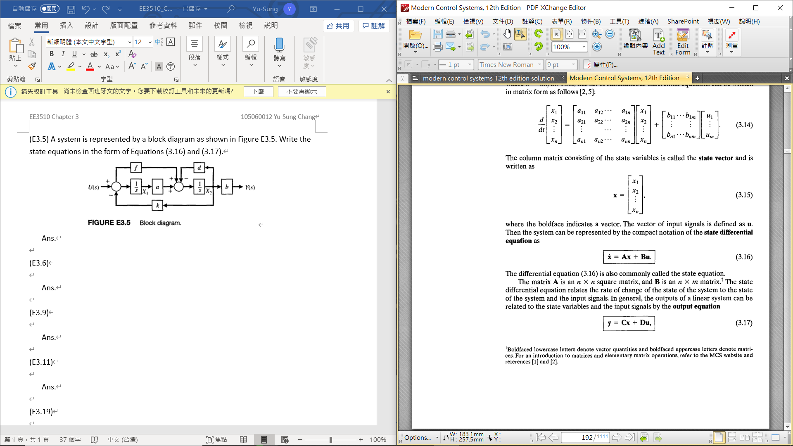

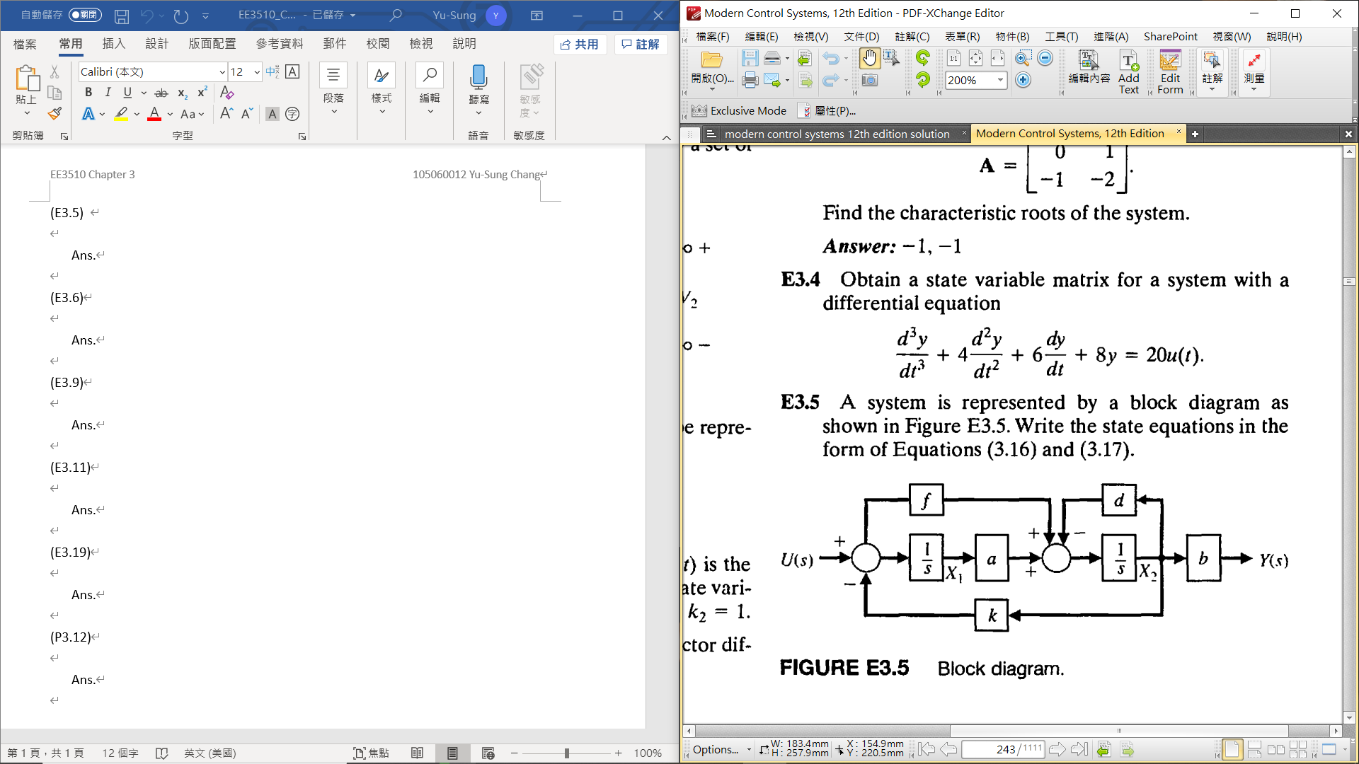

Ans.

$\frac{1}{s}\left(-fkX_{2}\left(s\right)-dX_{2}\left(s\right)+aX_{1}\left(s\right)+fU(s)\right)=X_{2}\left(s\right)⇒{\dot{x}}_{2}=-\left(fk+d\right)x_{2}+ax_{1}+fu$

$\frac{1}{s}\left(U\left(s\right)-kX_{2}\left(s\right)\right)=X_{1}\left(s\right)⇒{\dot{x}}_{1}=-kx_{2}+u$

* Therefore, $\dot{x}=Ax+Bu, y=Cx+Du$

$$A=\left[\begin{matrix}0 & -k \\ a & -\left(fk+d\right)\end{matrix}\right], B=\left[\begin{matrix}1 \\ f\end{matrix}\right], C=\left[\begin{matrix}0 & b\end{matrix}\right], D=\left[0\right], x=\left[\begin{matrix}x_{1} \\ x_{2}\end{matrix}\right], u=\left[u\right], y=\left[y\right]$$

(E3.6) A system is represented by Equation (3.16), where

$$A=\left[\begin{matrix}0 & 1 \\ 0 & 0\end{matrix}\right]$$

1. Find the matrix $Φ(t)$
2. For the initial conditions x1(0) = x2(0) = l, find **x**(t).

Ans.

1. The state transition matrix is $Φ\left(t\right)=e^{At}=I+At+\frac{1}{2!}A^{2}t^{2}+…$

$A^{2}=\left[\begin{matrix}0 & 1 \\ 0 & 0\end{matrix}\right]\left[\begin{matrix}0 & 1 \\ 0 & 0\end{matrix}\right]=0, thus A^{2}=A^{3}=A^{4}=…=0$

$⇒Φ\left(t\right)=e^{At}=\left[\begin{matrix}1 & 0 \\ 0 & 1\end{matrix}\right]+\left[\begin{matrix}0 & 1 \\ 0 & 0\end{matrix}\right]t=\left[\begin{matrix}1 & t \\ 0 & 1\end{matrix}\right]$

1. The state at any time t ≥ 0 is given by $x\left(t\right)=Φ(t)x\left(0\right)$

Since x1(0) = x2(0) = 1

$⇒x\left(t\right)=\left[\begin{matrix}1+t \\ 1\end{matrix}\right], x_{1}\left(t\right)=1+t, x_{2}\left(t\right)=1$

(E3.9) A multi-loop block diagram is shown in Figure E3.9. The state variables are denoted by x1 and x2.

1. Determine a state variable representation of the closed-loop system where the output is denoted by y(t) and the input is r(t)
2. Determine the characteristic equation.

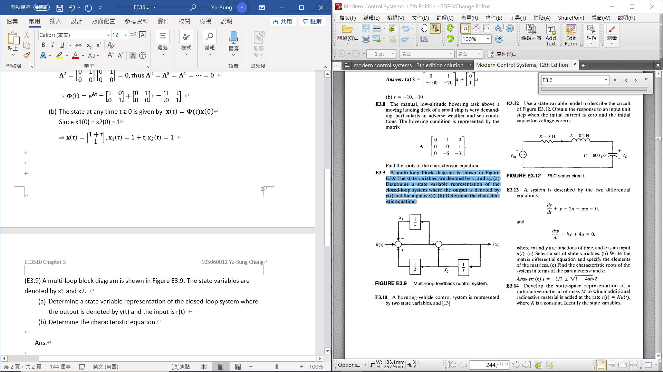

Ans.

* + - In state-variable form

$\dot{x}=\left[\begin{matrix}-1 & 0.5 \\ 1 & -1.5\end{matrix}\right]x+\left[\begin{matrix}1 \\ -1\end{matrix}\right]r, y=\left[\begin{matrix}1 & -1.5\end{matrix}\right]x+[-1]r$

1. The characteristic equation

$det\left[\begin{matrix}-1-s & 0.5 \\ 1 & -1.5-s\end{matrix}\right]=0→s^{2}+\frac{5}{2}s+1=(s+\frac{1}{2})(s+2)=0$

(E3.11) Determine a state variable representation for the system described by the transfer function

$$T\left(s\right)=\frac{Y\left(s\right)}{R(s)}=\frac{4(s+3)}{(s+2)(s+6)}$$

Ans.

$\frac{Y\left(s\right)}{R(s)}=\frac{4(s+3)}{(s+2)(s+6)}=\frac{4s+12}{s^{2}+8s+12}=\frac{4s^{-1}+12s^{-2}}{1+8s^{-1}+12s^{-2}}$ 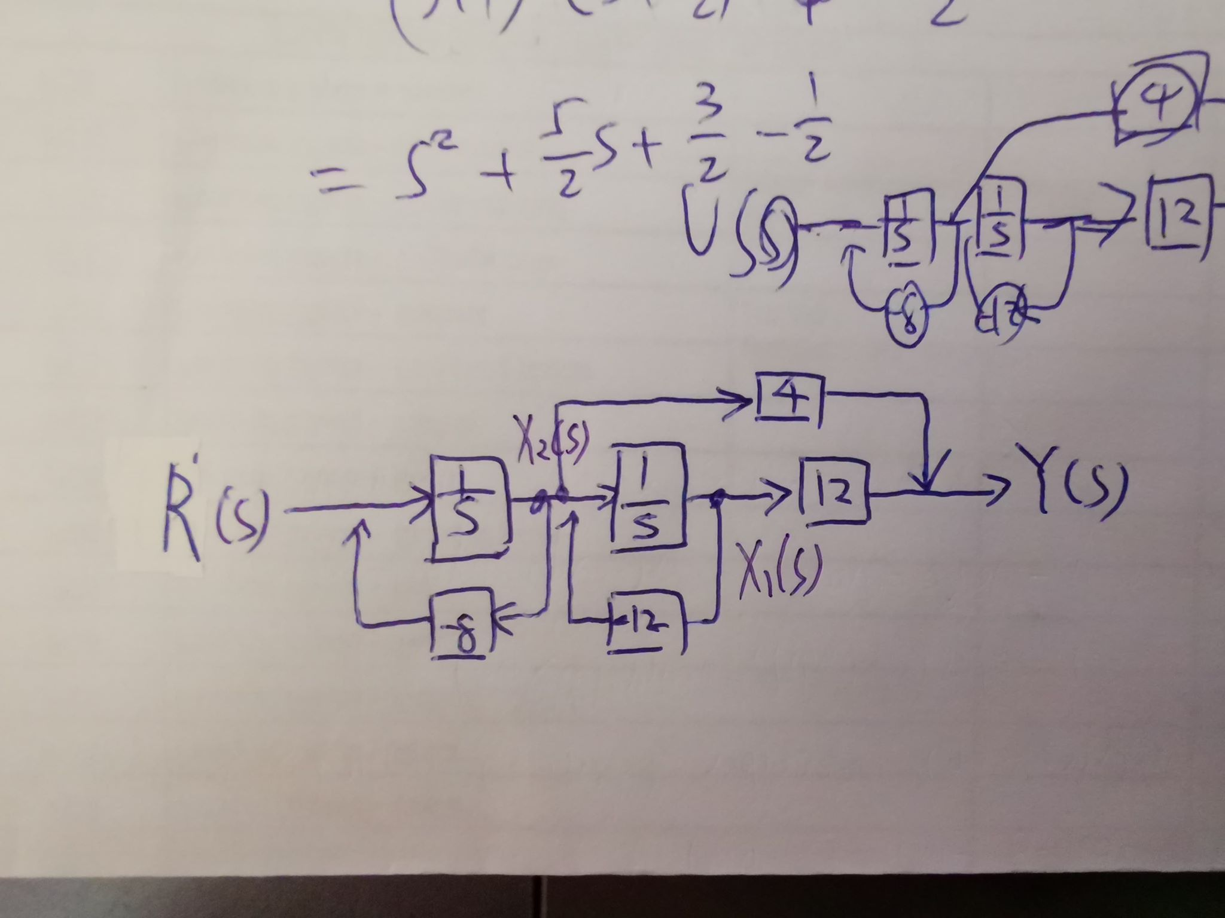



$X_{1}\left(s\right)=\frac{1}{s}\left(-12X_{1}\left(s\right)+X_{2}\left(s\right)\right)⇒{\dot{x}}_{1}=-12x_{1}+x_{2}$

$X_{2}\left(s\right)=\frac{1}{s}\left(-8X_{2}\left(s\right)+R(s)\right)⇒{\dot{x}}_{2}=-8x_{2}+r$

$Y\left(s\right)=12X_{1}\left(s\right)+4X_{2}\left(s\right)⇒y=12x_{1}+4x_{2}$

$\dot{x}=Ax+Br, y=Cx$

$⇒A=\left[\begin{matrix}-12 & 1 \\ 0 & -8\end{matrix}\right], B=\left[\begin{matrix}0 \\ 1\end{matrix}\right], C=\left[\begin{matrix}12 & 4\end{matrix}\right]$

(E3.19) A single-input, single-output system has the matrix equations

$$\dot{x}=\left[\begin{matrix}0 & 1 \\ -3 & -4\end{matrix}\right]x+\left[\begin{matrix}0 \\ 1\end{matrix}\right]u, y=\left[\begin{matrix}10 & 0\end{matrix}\right]x$$

Determine the transfer function G(s) = Y(s)/U(s).

Ans.

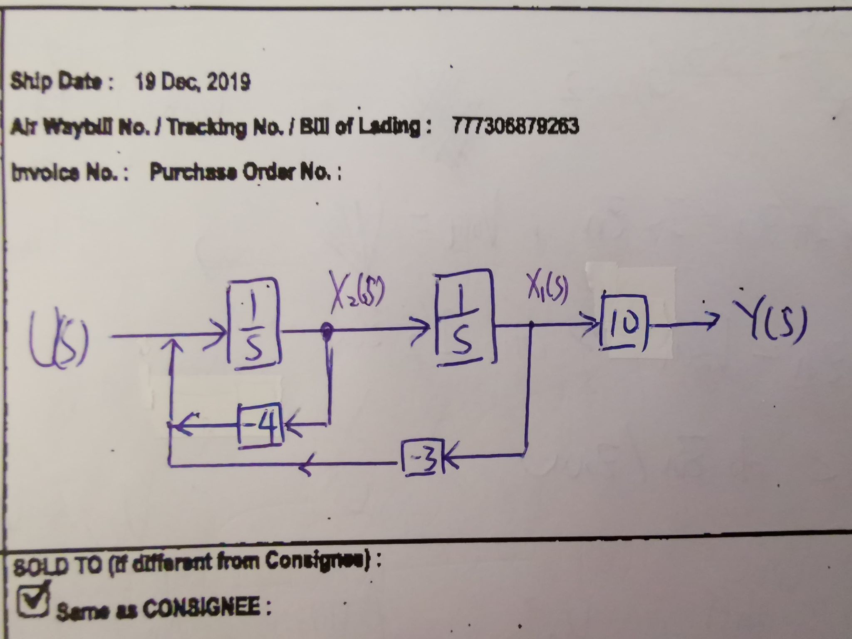

$G\left(s\right)=\frac{Y\left(s\right)}{U\left(s\right)}=\frac{10s^{-2}}{1+4s^{-1}+3s^{-2}}=\frac{10}{s^{2}+4s+3}$

(P3.12) A system is described by its transfer function

$$T\left(s\right)=\frac{Y\left(s\right)}{R(s)}=\frac{8(s+5)}{s^{3}+12s^{2}+44s+48}$$

1. Determine a state variable model.
2. Determine $Φ\left(t\right)$, the state transition matrix.

Ans.

$\frac{Y\left(s\right)}{R(s)}=\frac{8(s+5)}{s^{3}+12s^{2}+44s+48}=\frac{8s^{-2}+40s^{-3}}{1+{12}^{-1}+44s^{-2}+48s^{-3}}$

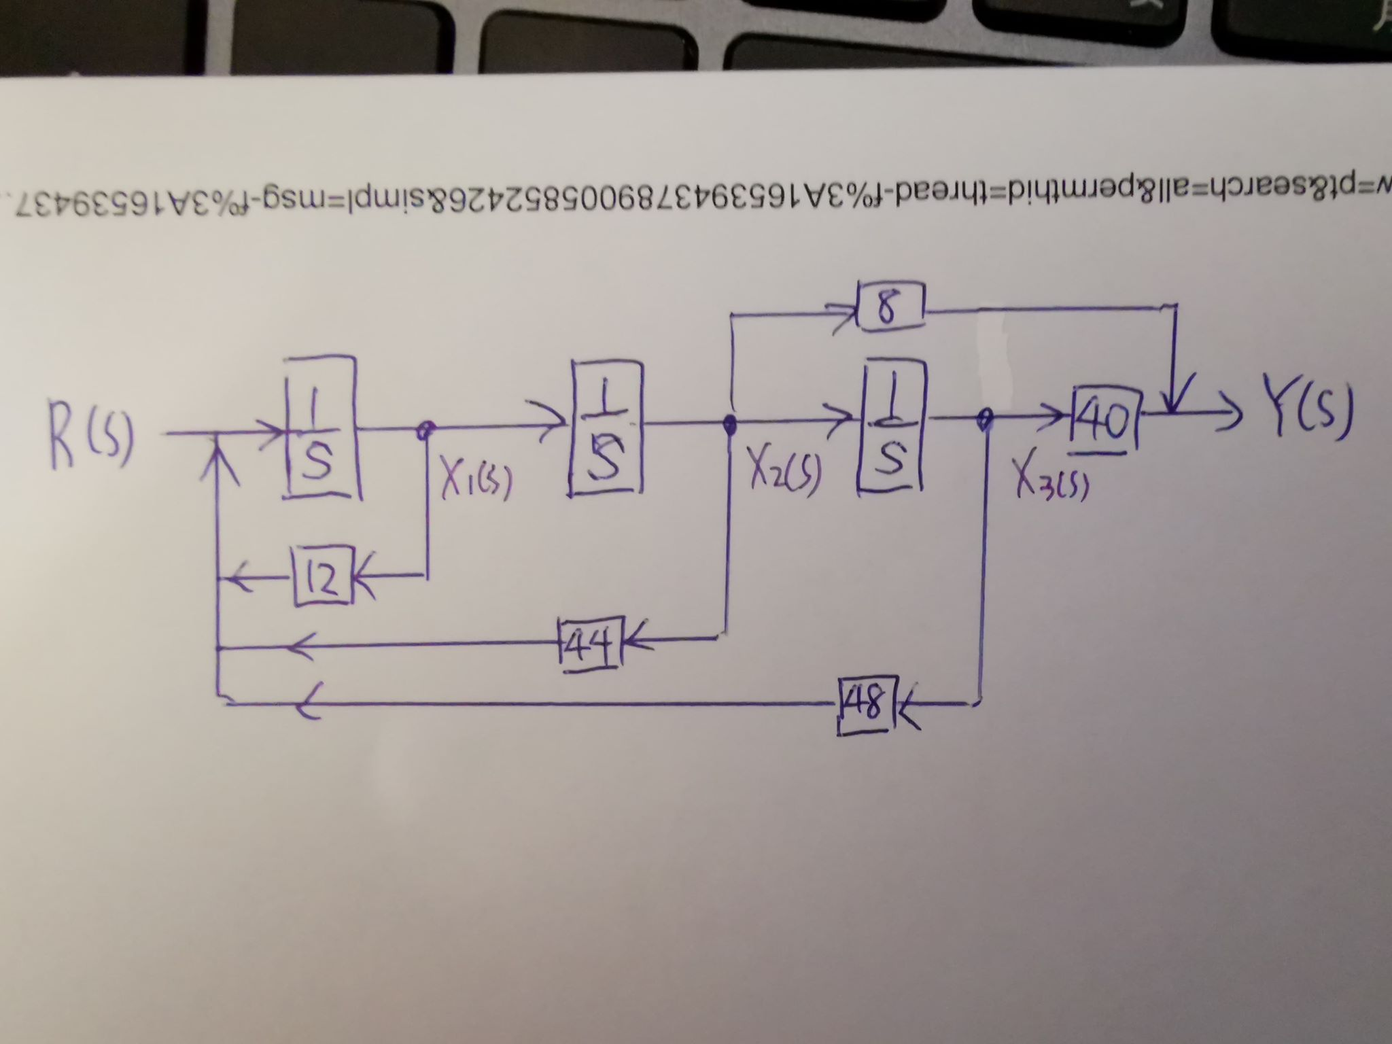

**-**

**-**

**-**

**3**

**1**

$\dot{x}=\left[\begin{matrix}0 & 1 & 0 \\ 0 & 0 & 1 \\ -48 & -44 & -12\end{matrix}\right]x+\left[\begin{matrix}0 \\ 0 \\ 1\end{matrix}\right]r, y=\left[\begin{matrix}40 & 8 & 0\end{matrix}\right]x$ $Φ\left(t\right)=e^{At}=[\begin{matrix}Φ_{1}\left(t\right) & Φ_{2}\left(t\right) & Φ_{3}\left(t\right)\end{matrix}]$ $A=\left[\begin{matrix}0 & 1 & 0 \\ 0 & 0 & 1 \\ -48 & -44 & -12\end{matrix}\right]Φ\left(s\right)={\left[sI-A\right]}^{-1}⇒Φ\left(t\right)$